**WINSCP,** Transfer file from [local machine] 🡪 [Cavium Cluster]

(Copy -paste, click & scroll)

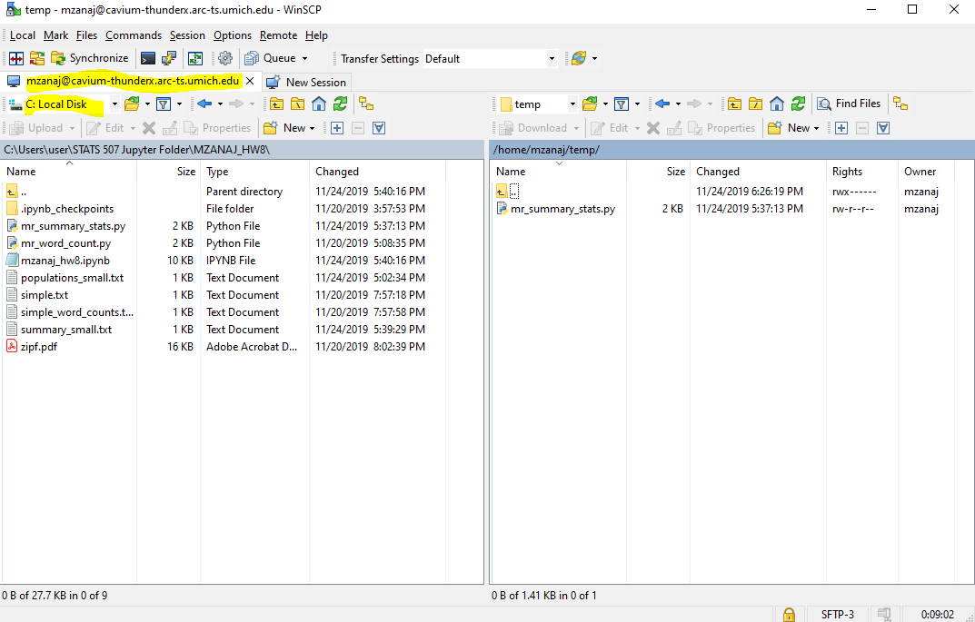

**Putty** , create a temp folder, and store python code in there

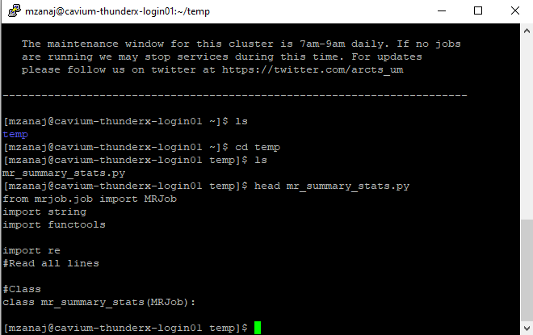

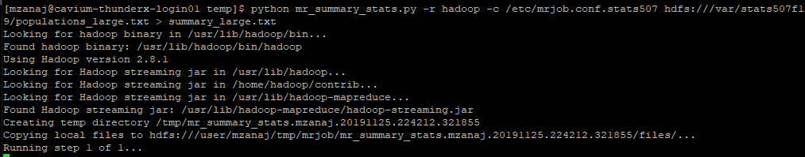**Hadoop**, Run python on Hadoop through Cavium

Job Info

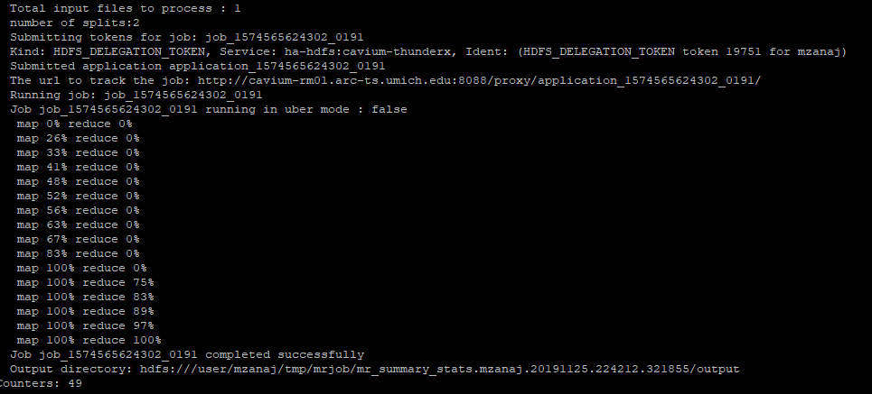



**Save Job,** from Hadoop to Cavium (cat), and from Cavium to the local machine (winScp)

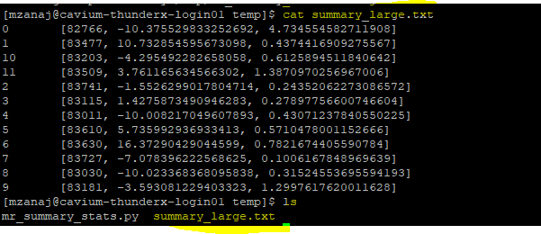

Cavium to local

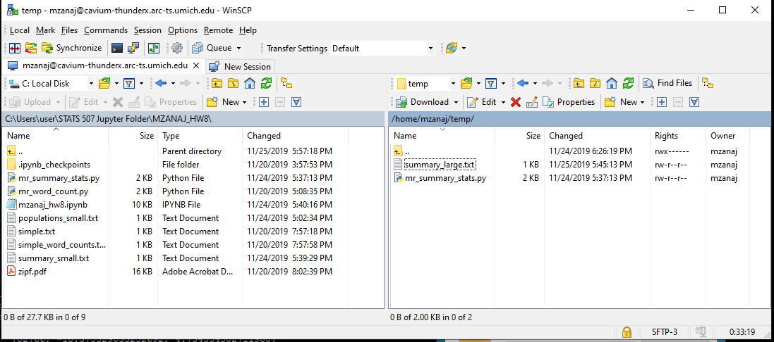

(Copy -paste, or click and scroll)

